**Lab 05 - Implement Intersite Connectivity**

***Mihail Elencevski***

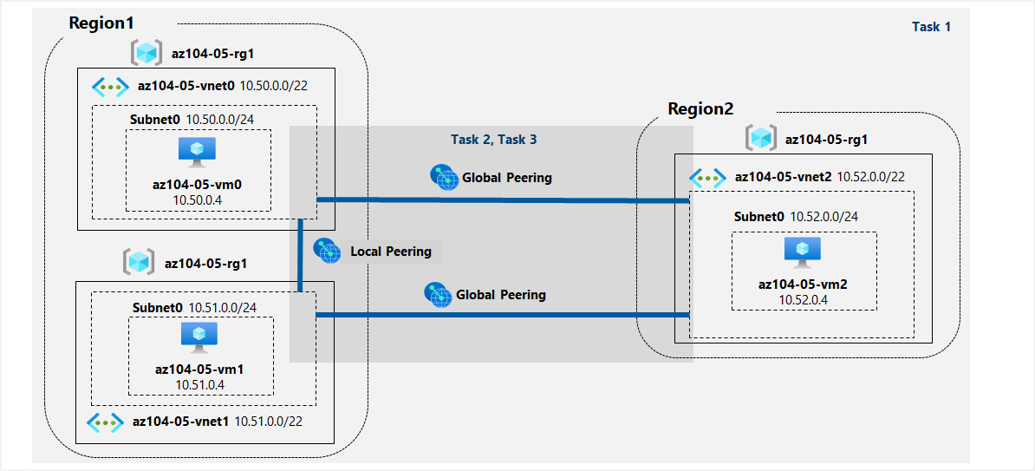

#### Task 1: Provision the lab environment

*After I uploaded the files*

***\Allfiles\Labs\05\az104-05-vnetvm-loop-template.json***

***\Allfiles\Labs\05\az104-05-vnetvm-loop-parameters.json***

*I changed the password in the* ***PARAMETERS*** *file with the command* ***code .***

*In the picture I am using Cloud Shell commands to create a resource group. Deploy two virtual networks and virtual machines in one Azure region, and one virtual network and machine in another Azure region.*

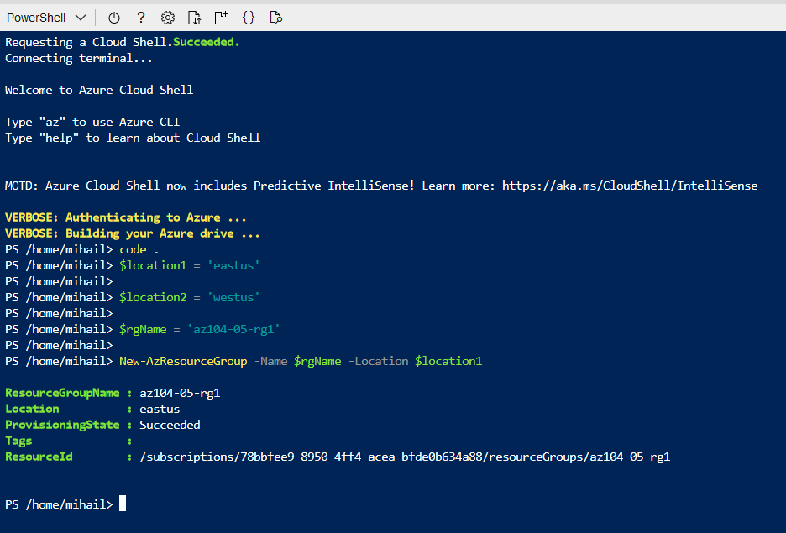

*Here I am creating the three virtual networks and deploy virtual machines into them by using the template and parameter files I uploaded:*

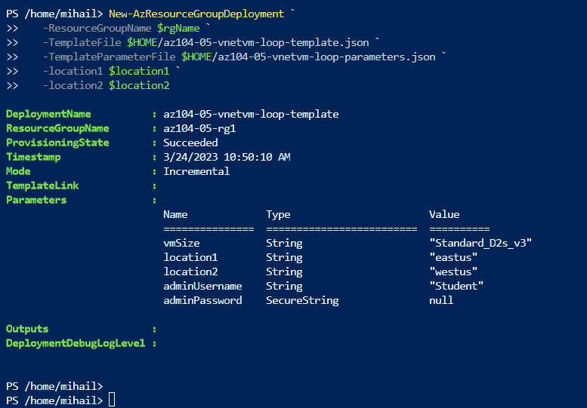

#### Task 2: Configure local and global virtual network peering

*I ran into an issue with the Azure portal interface not displaying the virtual networks I created so I had to confiqure peering using powershell commands.*

*$rgName = 'az104-05-rg1'*

*$vnet0 = Get-AzVirtualNetwork -Name 'az104-05-vnet0' -ResourceGroupName $rgname*

*$vnet1 = Get-AzVirtualNetwork -Name 'az104-05-vnet1' -ResourceGroupName $rgname*

*Add-AzVirtualNetworkPeering -Name 'az104-05-vnet0_to_az104-05-vnet1' -VirtualNetwork $vnet0 -RemoteVirtualNetworkId $vnet1.Id*

*Add-AzVirtualNetworkPeering -Name 'az104-05-vnet1_to_az104-05-vnet0' -VirtualNetwork $vnet1 -RemoteVirtualNetworkId $vnet0.Id*

*I did this commands (just with different VN names) for every Virtual network so I can establish global peerings.*

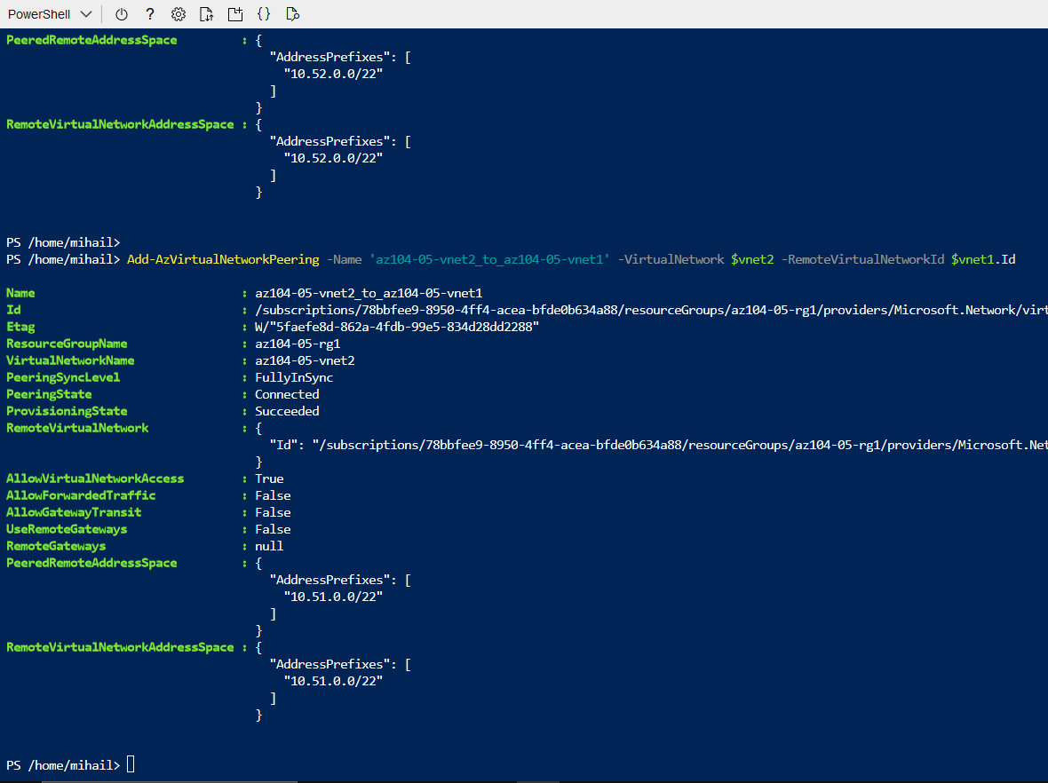

#### Task 3: Test intersite connectivity

*This step is essential for connectivity to all Virtual Machines in this case the three.*

*In this picture I am entering my credentials so that I can connect to the VM to test the connectivity. This was required for all the 3 VMs.*

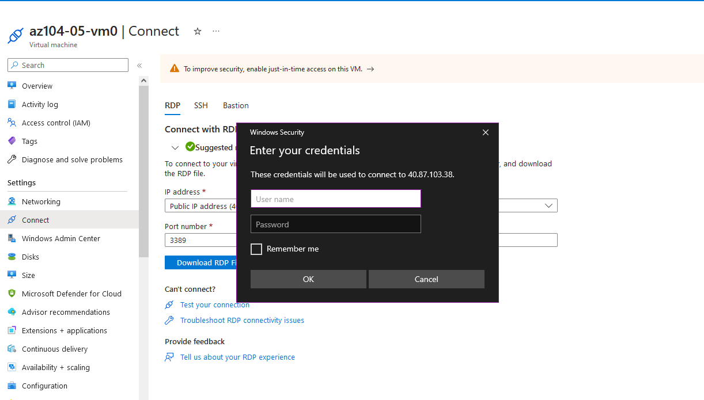

*Testing connectivityi to* ***az104-05-vm0*** *(which has the private IP address of* ***10.51.0.4****) over TCP port 3389:*

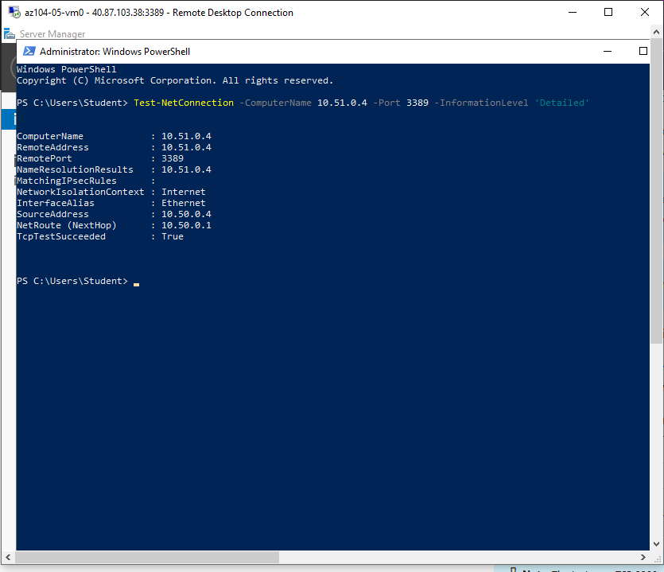

*Testing connectivityi to* ***az104-05-vm1*** *(which has the private IP address of* ***10.52.0.4****)) over TCP port 3389:*

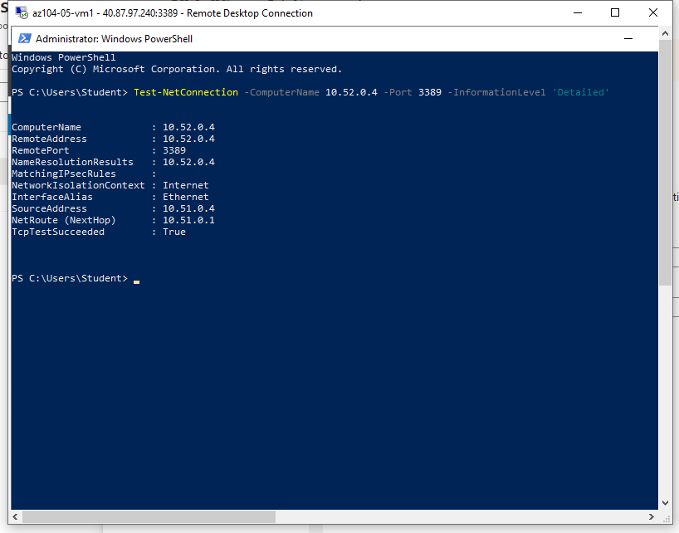

Testing connectivityi to **az104-05-vm2** (which has the private IP address of **10.52.0.4**)) over TCP port 3389:

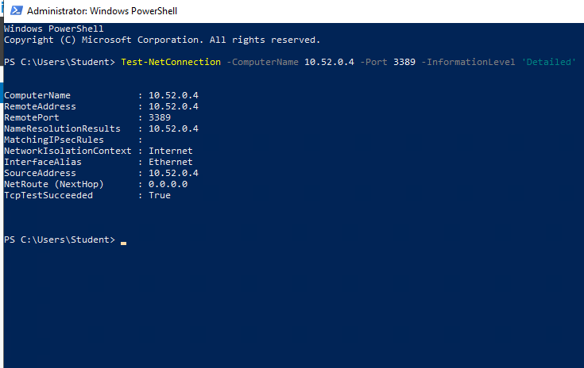

**Succesfull test of the connections**

Cleaning up resources